
R-7/Vostok instruction page 01 of 03

R-7/ Vostok instructions

The Model
The Model is based on a russian drawing. It's made in scale 1:100, but can also be printed out
in other sizes. The sheets are very large. To get the best quality, print the sheets out as this;
1.100: Print the sheets out in "fit to page" (A4 only), or set the printing size to 29%
1.144: Set the printing size to 21 %
The model is build of 190 gr cardbord, but should be made on thinner cardboard if made in
size 1:144.
Like on the R7-Sputnik page 3 and 7 are backside print for page 2 and 6, and there are
two extra vernier nozzles on the page 6. These are for the second stage.

The Launcher
Build the launcher after the directions for the R7-Sputnik. Just put the flameshield (2M)
instead of the Sputnik top.

Vostok Top
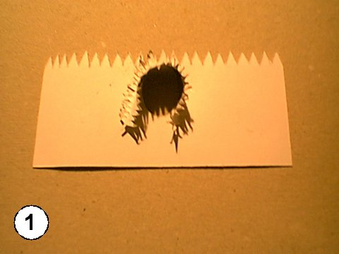
Glue the conical section (8H) to the vostok shroud (8A). The curveved
side shal be outward, and there's a little marker on both to show where to
start. Glue the conical section all the way around, and end with a little over-
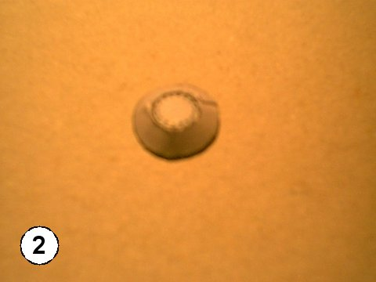
lap. Let dry.

R-7/Vostok instruction page 02 of 03

Glue the vostok top together (8G and 8J). Let dry.
Cutout lower secetion (8C), and glue to cylinder. Glue the back end
on. Cutout strip (8C) and fit to inside of lower section. Glue to cylinder ,
but do not glue to indside of bottom. Glue intersection (8B) to out-
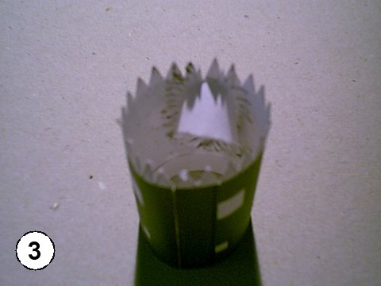
side of strip. Make sure it fits to bottom section.

Glue plate (8F) into top of upper section, Glue the three sections together.
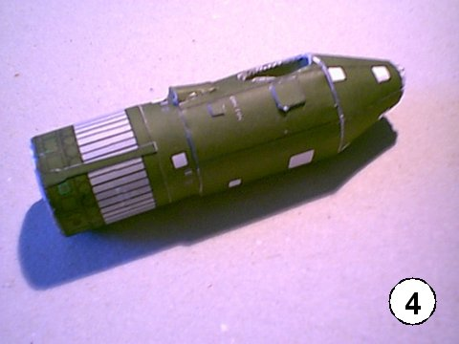

Glue fittings on. 8P are to be folded backward, and glued on pointing upwards.
8Q is to be folded 90 degree backward an glued o. Glue 8R to the top of
8Q. The wenier rockets (see Pic. 6) is made of three pieces. 8S is folde to a tri-
angle, roll 8O around penciltip to a cone, and glue to end of triangle, pointing
uipward. The vernier rocket (3M) is rolled around penciltip, and inserted into
cone (8O). Glue the vostok topv to the R-7 booster with the girder (2E),
there are markers on both.

R-7/Vostok instruction page 03 of 03

