
Rr-transporter instructions page 01 of 11

R-7 railroad transporter

Before you begin, please read the following

The sheets are very large, and are to be printed out as follows

1:100; print in ”fit to page” (A4 only) or 29%
1:144; print in 20%

The kit consist of ca. 60 parts, and are not for beginners

The ref. numbers in the text correspond to the sheets. Part
4D is part D on page 4, and so on.

The prototype is made on 190 gr. cardboard in 1:100 scale

One of the pages, page 2 is backside print for page 1. If you
don’t want to cut out all the holes in the parts for the gantry,
it’s a lot of work, but it’s worth it, you can dye the holes black,
and omit the backside print on page 1. Page 8 are to be printed
in 2 copys.

Page 1-5 is the transporter itself
Page 6-8 is the stand for the model (vertical and horizontal display)
Page 9 is a low stand for the model (horizontal display only)
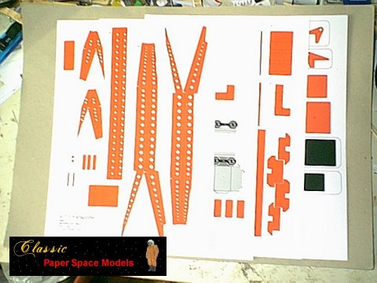
To make the model, you need one set of sheets, a barbecue pin,
(ca 2,5 mm), and a paperclip or a piece of thin wir

Rr-transporter instructions page 02 of 11

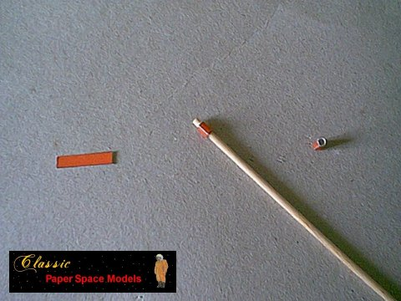
Start with the axils. Part 1H, 3 pieces, are rolled to cylinders fitting losely around
a barbecue pin and glued together. Repeat the procedure with part 3I.
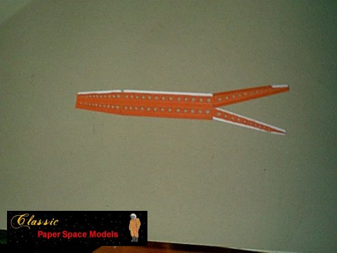
Continue with the gantry arms, 1B-C, for best result, precut the folding lines with a
dull knife, cutout the part, prefold all the folding lines, and then cutout the holes.
The cyan holes is for the axils. Glue the cylinders 1H inside them.
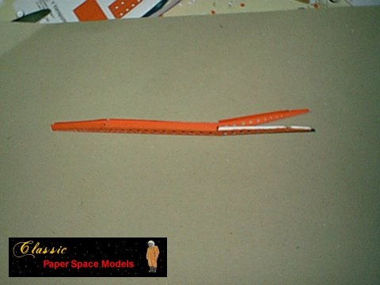
Fold and glue the gantry arm together. It’s a good idea to glue 1 flap at a time, and then let it dry a little before continuing. Evt. Shift between the two.

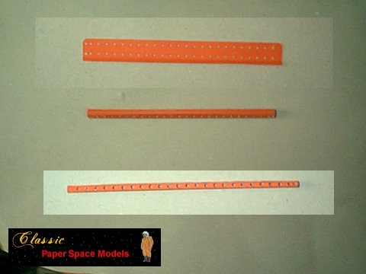
Rr-transporter instructions page 03 of 11

Continue with the main beam,1A, it’s the same procedure as the gantry arms, fit the cylinder into the cyan hole.
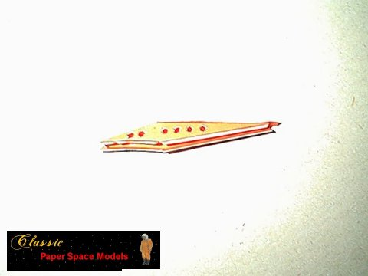

The top of the gantry, 1D-E, is made as the gantry arms.

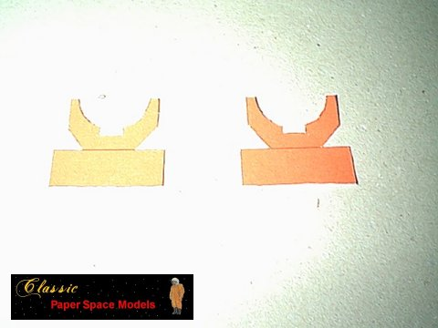
Top holders, 5A, glue back to back. Fold and glue 5B, 4 pieces, to a triangle.
Fold 5A 90 degree and glue two of the triangles inside for support. Fold and glue 5C and 5Q back to back. Cutout and glue 5F back to back

Rr-transporter instructions page 04 ofb 11

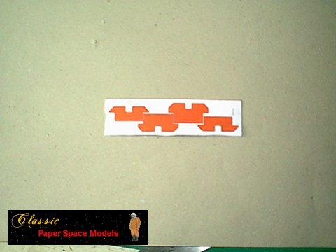
4B. fold and glue back to back, coutout when dry. Make shure to keep them in the
right order. Coutout and glue 5G and 5H back to back. Fold 5H 90 degree and glue triangle, 5B, into corner as strenghter.
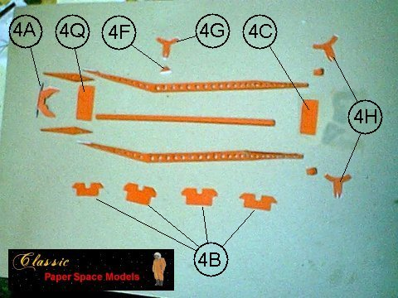

All the parts for the gantry arm. When gluing together, make shure that a barbecue
pin fit into the axil holes in the gantry-beams.

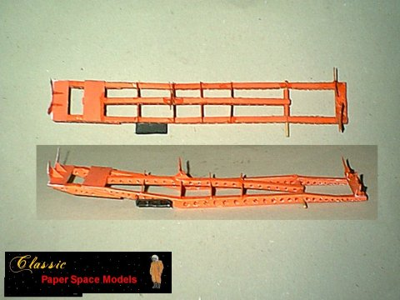
Finished gantry arm. Please nototic the barbecue pin. The cylinders 3I, fits around the
Rr-transporter instructions page 05 of

pin inside the gantry-beams. When mounting the middle supporter, make sure it fits to the middle section of the R7-launcher, evt. trim the part, 5G, a little.
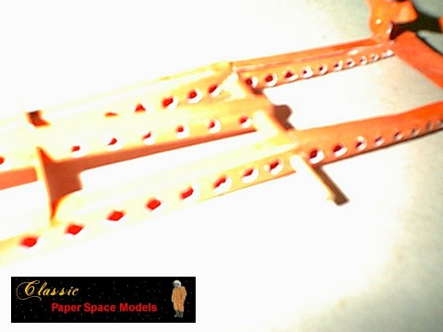

Cutout and glue the railings 5N and 5O back to back. When dry, cutout,fold, and glue 5N to Gantry-arm.
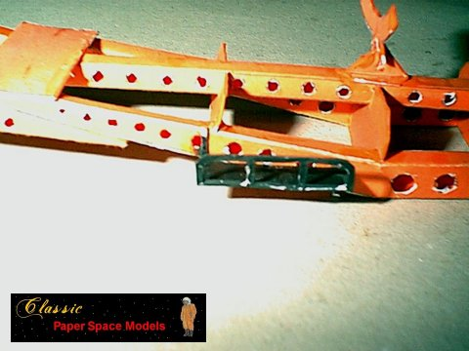
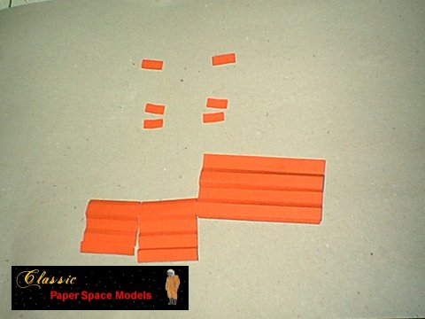
Mount the railing 5N, as picture.

Parts for a beam to the rr-wagon, 3B, 4A. Please notice the strenghtners. They are to
Rr-transporter instructions page 06 of

be glued into the bends of the beam. The straight ones for the vertical flanges, and the bended ones for the horizontal flanges. Bend the part into a I-beam.
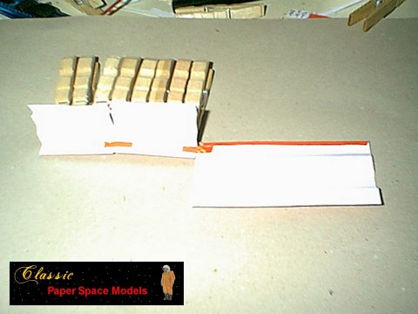

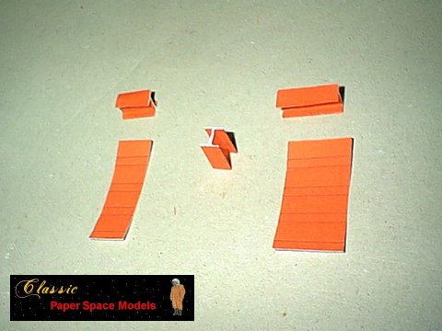
It’s a good idea to use some cloth-pegs or other kind of clamps, when the I-balk is glued.

The spacers for the rr-wagon, 4E-F, They are to be glued into I-beams. Please note,
that the large fields don’t have the same size, so be sure it’s fit before start gluIng.
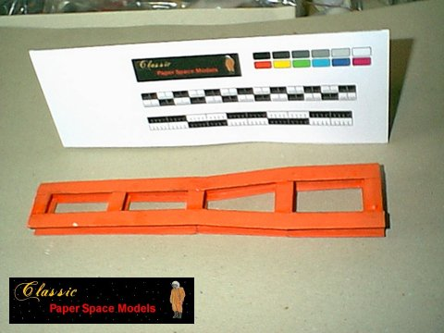
The finished rr-wagon bottom. Glue the spacers inside the main beam.
Rr-transporter instructions page 07 of

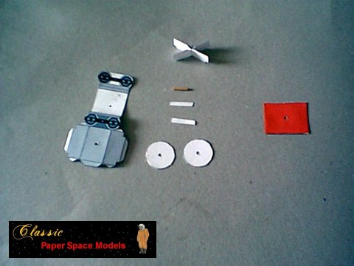
The parts for a set rr-wheels. Notice the bbq-pin (1 cm), it’s
Used for axil between the wheels and bottom plate. Glue the wheel-box, 3C, Together. Place the strenghters inside the box. The notch shall be in the top End. Glue a strip, 3H,
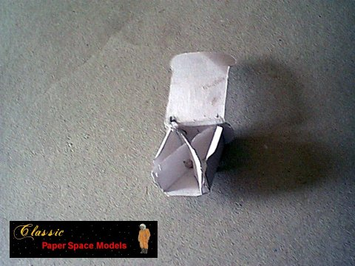
around bbq-pin, and place inside the box, sticking up. Notice the notches in the bottom sides of the box. Glue them carefully so they fits into the rr tracks.

There might be a little mismatch, due to cardborad thickness, it can be nessecery to
trim some of the parts for perfect fit.
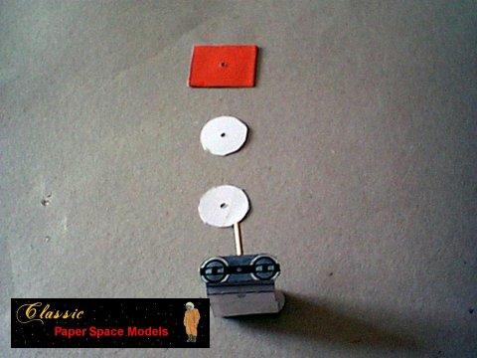

Rr-transporter instructions page 08 of

Finished rr wheels. The top plate is 3M, 2 pieces, glue back to back and cut out the
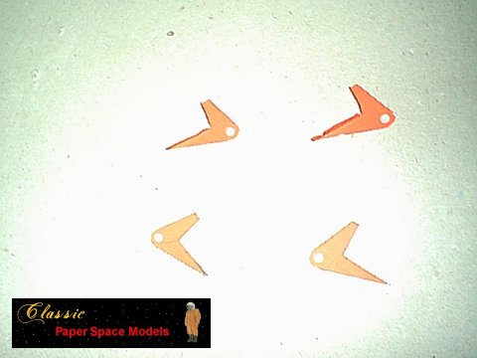
hole. Mount the wheel-set with the discs, the top plate and finish with gluing a strip around the bbq-pin to secure.

Glue the hinges, 5J-K, back to back

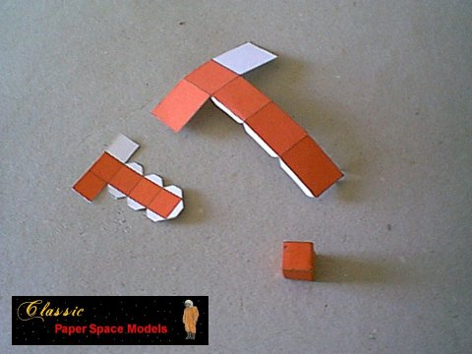
3E, 4G and 5P. Glue to boxes. Fold and glue 1F and 1K back to back.

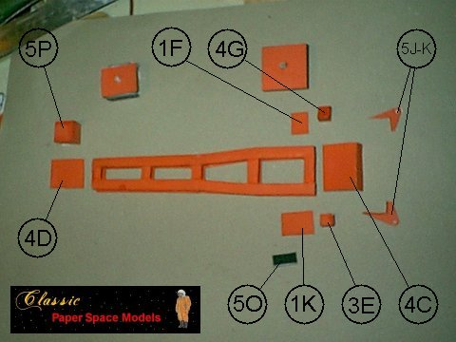
The finished parts for the rr-car. 4C and D are glued to the top ends of the platform,

Rr-transporter instructions page 09 of

1F and 1K are glued to the underside of the top flange. 5P are glued to the top of 4D.
4G and 3E are glued to the top of 1F and K parallel to echother. The hinges, 5J-K, are glued to the top of 4C, flanges inward. The raling, 5O, are glue on beside 3E. The wheels are glued to the backside, ca 1 cm. From the ends.

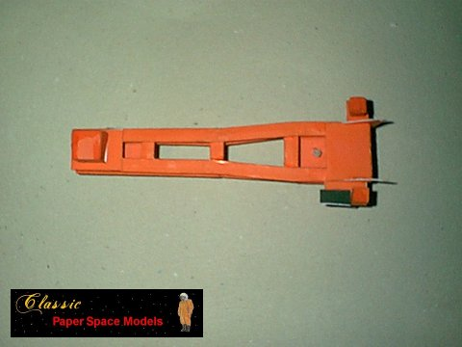
Finished railroad car. Integrate the two parts at the hinges with a bbq-pin. Place the cylinders, 3I, around the bbq-pin indside the beams. Cutof the pin 2 mm. From hinges.
Roll 1I around the pin to secure, and finish with the end-plate 1G.

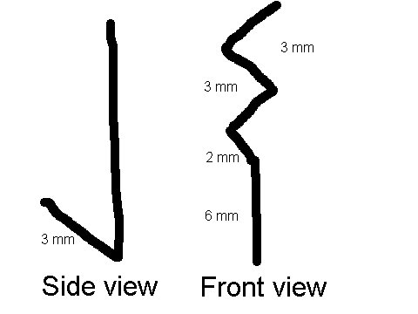
Make two hooks of the wire, a 3mm hook in one end, and a little zig-zag in the other.

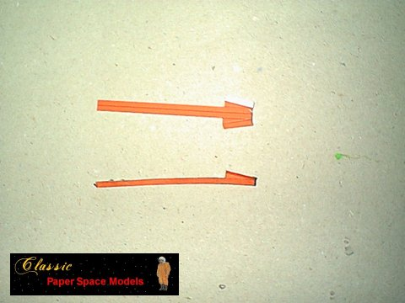
Cutout, fold and glue 1L. glue the hook inside the thin end, so the hook is on the red side.

Rr-transporter instructions page 10 of
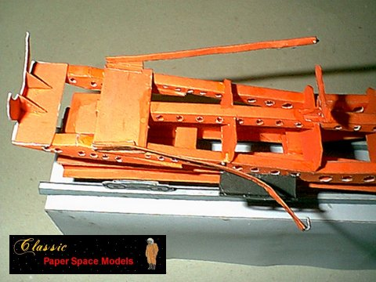

Glue the two arms to the inside of the platform, white side down, and hooks pointing inwards.

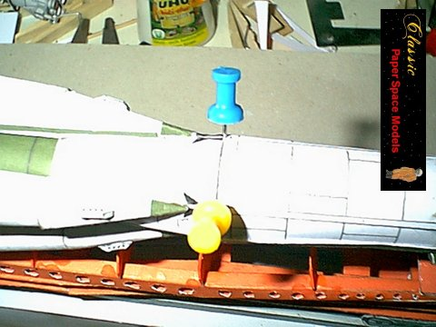
Make two holes at the backside of the booster for the hooks. They shall be placed 90 degree from each other at the backside of the booster.
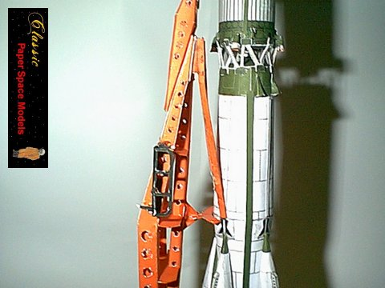
Now the model can be placed in the transporter, hanging in the hardring, as it’s done on

Rr-transporter instructions page 11 of

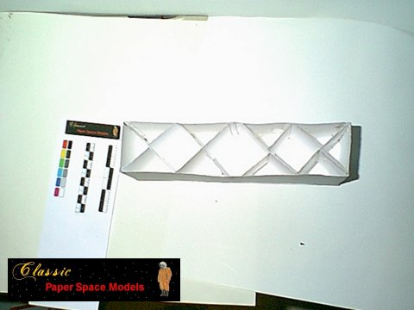
the real one.

Cut, fold and glue the display stand. Glue the supporters, 8A, inside the stand. The low stand are made the same way. Fold and glue the rr tracks, and glue to cyan line on stand.
If the model is to be displayed verticeal, it need a little weight, ca 25 gr. in the front end, or easier, glue the wheels to the stand.

